**NAMA : VIA DWIFA  
NIRM : 2018020908  
KELAS : 5SIA10**

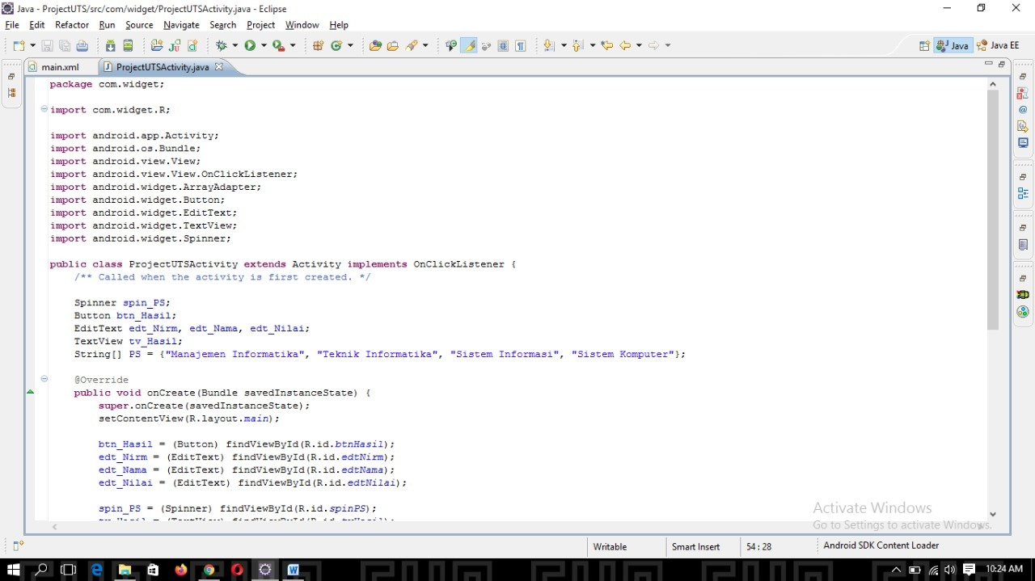

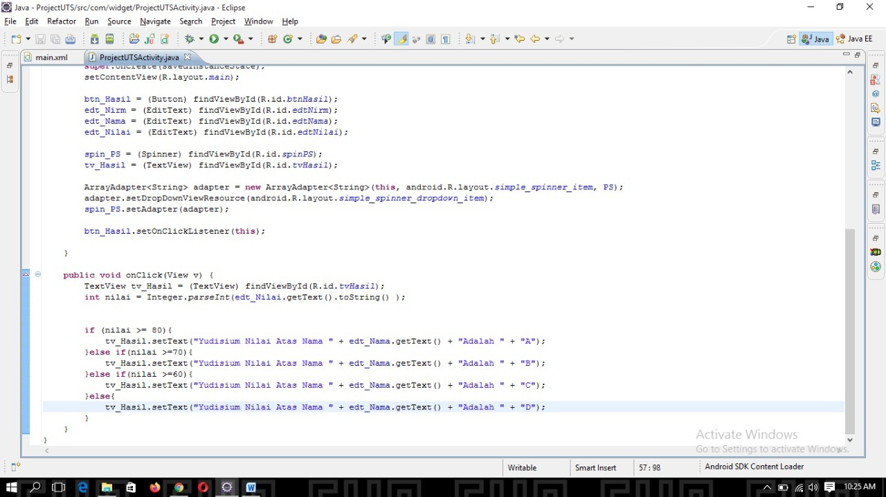

package com.widget;

import com.widget.R;

import android.app.Activity;

import android.os.Bundle;

import android.view.View;

import android.view.View.OnClickListener;

import android.widget.ArrayAdapter;

import android.widget.Button;

import android.widget.EditText;

import android.widget.TextView;

import android.widget.Spinner;

public class ProjectUTSActivity extends Activity implements OnClickListener {

/** Called when the activity is first created. */

Spinner spin_PS;

Button btn_Hasil;

EditText edt_Nirm, edt_Nama, edt_Nilai;

TextView tv_Hasil;

String[] PS = {"Manajemen Informatika", "Teknik Informatika", "Sistem Informasi", "Sistem Komputer"};

@Override

public void onCreate(Bundle savedInstanceState) {

super.onCreate(savedInstanceState);

setContentView(R.layout.main);

btn_Hasil = (Button) findViewById(R.id.btnHasil);

edt_Nirm = (EditText) findViewById(R.id.edtNirm);

edt_Nama = (EditText) findViewById(R.id.edtNama);

edt_Nilai = (EditText) findViewById(R.id.edtNilai);

spin_PS = (Spinner) findViewById(R.id.spinPS);

tv_Hasil = (TextView) findViewById(R.id.tvHasil);

ArrayAdapter<String> adapter = new ArrayAdapter<String>(this, android.R.layout.simple_spinner_item, PS);

adapter.setDropDownViewResource(android.R.layout.simple_spinner_dropdown_item);

spin_PS.setAdapter(adapter);

btn_Hasil.setOnClickListener(this);

}

public void onClick(View v) {

TextView tv_Hasil = (TextView) findViewById(R.id.tvHasil);

int nilai = Integer.parseInt(edt_Nilai.getText().toString() );

if (nilai >= 80){

tv_Hasil.setText("Yudisium Nilai Atas Nama " + edt_Nama.getText() + "Adalah " + "A");

}else if(nilai >=70){

tv_Hasil.setText("Yudisium Nilai Atas Nama " + edt_Nama.getText() + "Adalah " + "B");

}else if(nilai >=60){

tv_Hasil.setText("Yudisium Nilai Atas Nama " + edt_Nama.getText() + "Adalah " + "C");

}else{

tv_Hasil.setText("Yudisium Nilai Atas Nama " + edt_Nama.getText() + "Adalah " + "D");

}

}

}